Available online at [www.sciencedirect.com](http://www.sciencedirect.com/)



**ScienceDirect**

Procedia Computer Science 135 (2018) 465–472

3rd International Conference on Computer Science and Computational Intelligence 2018

Design of Smart Home Security System using Object Recognition and PIR Sensor

Nico Suranthaa, Wingky R. Wicaksonob

*a,bComputer Science Department, BINUS Graduate Program - Master of Computer Science, Bina Nusantara University, JI kebon Jeruk Raya No 27, Jakarta 11480, Indonesia*

**Abstract**

This research aims to design and implement a home security system with the capability for human detection. The traditional home security system, i.e. closed circuit television (CCTV) can only capture and record the video without able to give warning feedback if there is any suspicious object. Therefore, an additional object detection and warning method is required if there is an intruder. The proposed design is implemented using Raspberry Pi 3 and Arduino, which are connected by USB cable. The PIR sensor is installed on the Arduino and the webcam is mounted on Raspberry Pi 3. The Raspberry Pi 3 is used to process inputs from received sensors and process images for human detection. The PIR sensor detects the movement around the sensor to activate the webcam to capture a picture. Then, the object recognition is performed using histogram of gradient (HoG) and support vector machine (SVM) to detect the suspicious object. If the suspicious object is detected, then alarm is activated to warn the house owner about the existence of intruder. The evaluation results show that it takes in average 2 seconds for proposed system to detect the intruder. It also shows that the system can successfully detects the intruder with accuracy of 89%.

© 2018 The Authors. Published by Elsevier Ltd.

This is an open access article under the CC BY-NC-ND license (https://creativecommons.org/licenses/by-nc-nd/4.0/)

Selection and peer-review under responsibility of the 3rd International Conference on Computer Science and Computational Intelligence 2018.

*Keywords:* Home Security, Raspberry Pi 3, Arduino, PIR Sensor, Object Recognition

1877-0509 © 2018 The Authors. Published by Elsevier Ltd.

This is an open access article under the CC BY-NC-ND license (<https://creativecommons.org/licenses/by-nc-nd/4.0/>)

Selection and peer-review under responsibility of the 3rd International Conference on Computer Science and Computational Intelligence 2018.

10.1016/j.procs.2018.08.198

# Introduction

The house is a residential building, asset, as well as a place to store wealth. Therefore, security becomes one of the mandatory consideration in keeping the house from undesirable event or accident. The traditional solution for house security is a closed-circuit television (CCTV). CCTV is a device to monitor the situation around the office area, house, and building. CCTV is also a very useful device to monitor the circumstances around the house, either when the residents are at home or not at home 1. There are some problems with CCTV implementation. Firstly, it does not produce any notification and warning whenever it captures any suspicious object. Secondly, CCTV is streaming continuously to capture the events that occur in the home environment even when there is no any suspicious object or activity. Therefore it results in huge consumption of bandwidth and storage media due to the continuous video streaming and storing.

Internet of things (IoT) is a network of interconnected electronic devices that capable of sending data without interference or with minimal human intervention. This technology is widely used for smart city application, personal health monitoring, manufacturing and smart lighting. Some researchers have developed security monitoring system based on IoT concept 2,3. They utilize the capability of sensor, e.g. passive infrared (PIR) motion sensor, door open sensor, glass break detector to monitor the occurrence of any suspicious activity. The system is also equipped with feedback mechanism to warn the house owner if there is any intruder enters their home. In general, this technology offer better protection compared to the traditional CCTV.

In this paper, we propose the IoT system to monitor the presence of intruder in the house by using combination of motion detection and object recognition. The motion detection is performed using PIR sensor 4,5. After the motion of object is detected, the web camera takes the picture of the suspicious spot. The system then perform object recognition by using histogram of gradient (HOG) 6 and support vector machine (SVM) methods. Finally, system is expected to recognize the appearance of intruder and warn the house owner via alarm. The system is implemented on Raspberry pi3 and Arduino. The evaluation of the system includes the measurement of accuracy and delay of intruder recognition. The system is expected to recognize the intruder accurately in shortest time.

The structure of the paper is divided into five sections. Section II discusses previous work that has been done by researchers in this field. Section III is the section that describes the system design approach. Section IV presents performance evaluation results and discussion. Finally, section V concludes the result of this research.

# Related Work

Previously, there were some of research have been done about home security system. The first research has been done by S. Tanwar, P. Patel, K. Patel, S. Tyagi, N. Kumar and MS Obaidat entitled "An Advanced Internet of Thing based Security Alert System for Smart Home" 7. It describes inexpensive home security systems using Infrared (PIR) and Raspberry Pi modules to minimize delays during e-mail alerts. Therefore, there are PIR sensors as motion detection and Raspberry Pi as its processing module 7.

Secondly, there was a research conducted by Jayashri Bangali and Arvind Shaligram entitled "Design and Implementation of Security Systems for Smart Home based on GSM technology" 1. It suggests two methods for home security systems that are implemented into one application. The first system uses a web camera that is useful for capturing motion and object, warning sounds and sending feedbacks to the user. The second method sends SMS using module GSM-GPS Module (sim548c) and Atmega644p microcontroller, sensor, relay and buzzer 1.

The third study was conducted by Renuka Chuimurkar and Vijay Bagdi entitled "Smart Surveillance Security & Monitoring System Using Raspberry PI and PIR Sensor" 5. It discusses the design and implementation of monitoring systems using Raspberry Pi and PIR Sensors for mobile device. The system has the ability to detect smoke detection and human detection that can provide precautions against potential crime and potential fire. The hardware it uses is using Raspberry Pi (RPI) with OpenCV addition to handle image processing, alarm control and send captured photos to user email via WiFi8 Alarm system for the initial sign, the system will play the sound recording: "intruder" or "smoke detected" when there is detection 5.

From the literature review that have been discussed, there are few researchers that discusses the IoT, home security system, and motion detection. However, it can be concluded that there is no researcher specifically

discussing IoT technology for home security with the additional ability to recognize the intruder. Therefore, in this research we propose our design to maximize the existing system and provide better feedback to the user.

# System Design Approach

Based on the problems faced, we propose an IoT system with additional capability to detect and recognize intruder using HOG and SVM methods 6,8. The system is implemented on Raspberry Pi 3 9,10 and Arduino 11,12. The Raspberry Pi 3 is used because this board can process image processing with low power from computer and laptop. The Arduino is used to integrate all the electronic devices in one environment. To detect the motion, the PIR sensor is utilized13. In this section, we discuss the system design approach for the proposed home security system.

* 1. *Overall System Design*

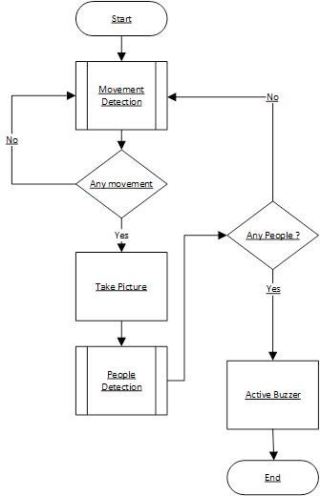In designing a system, the first step is to develop the architecture of the system. Firstly, we need to consider the scenario of possible intruder entry and scenario how the warning is informed. From a possible intruder scenario, it can be seen in the “Arrival of Intruder” section in Fig 1. In this research, we assume the intruder to enter the house from the front door. From the arrival of intruders, the PIR Sensor that is located near the front door is the first component to be activated when detect the motion of intruder. The PIR sensor read every movement that passes through the detection range of the PIR sensor, i.e. approximately 5-7 meters. In the process of motion detection, the system will read continuously until a movement is found.

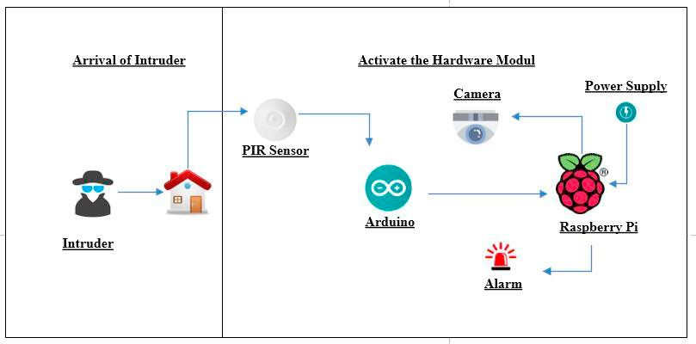

Fig. 1. Proposed System Architecture.

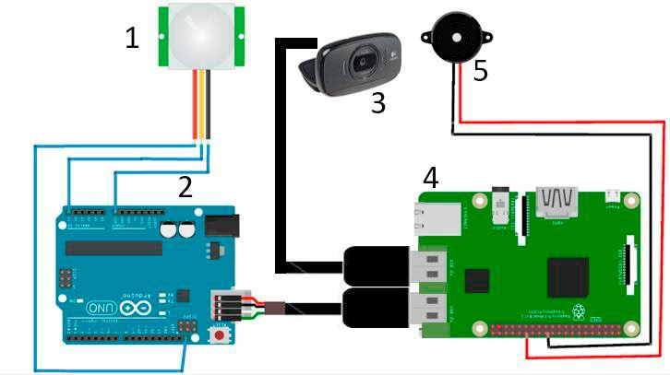

Fig. 3. Hardware Architecture Fig. 2. System Workflow

If there is movement then the system will activate the camera. The resulting images are then stored in the system

directory. After the photo capture and storage process, the system will activate the function for human detection. In human detection, we use the HOG and SVM methods. Features of the photo are extracted using HOG and then a classification of features is performed by using SVM. SVM matches the features of the photos with features in the dataset. If a photo has human presence then the system will activate the buzzer as an alarm. If there is no human presence in the picture then the system will re-read the movement or return to the initial process. The system complete system work flow is defined by Fig. 2

* 1. *Hardware Design*

In this section, we discuss about the hardware design. The hardware design includes the selection of electronics equipment and the integration of all of components. Figure 3 shows the hardware design for our security monitoring system. While, specification of every component are defined by table 1. The number in figure 1 corresponds to the order of component in table 1. For processing module, we use Raspberry Pi 3 model B. This board is equipped with wireless LAN module for communication. Arduino is used to collect the signal from PIR sensor through jumper cable. Arduino is connected to Raspberry Pi via USB cable. To capture the picture, USB web cam is mounted to the Raspberry Pi 3 via USB cable. To release warning, buzzer module is connected to Raspberry Pi 3 through GPIO port.

Table 1. Hardware Module.

|  |  |  |
| --- | --- | --- |
| No | Name | Description |
| 1 | PIR Sensor | PIR Sensor for movement detection |
| 2 | Arduino | Arduino Uno |
| 3 | Camera | Using webcam camera USB 2.0 (Logitech c525) for take picture |
| 4 | Raspberry Pi | Using Raspberry Pi 3 Model B, ARM Cortex-A53 1.2 GHz, 1 GB RAM,  802.11n wireless LAN. In this Raspberry Pi 3 image processing has been installed (OpenCV) |
| 5 | Buzzer | Passive buzzer for alarm |

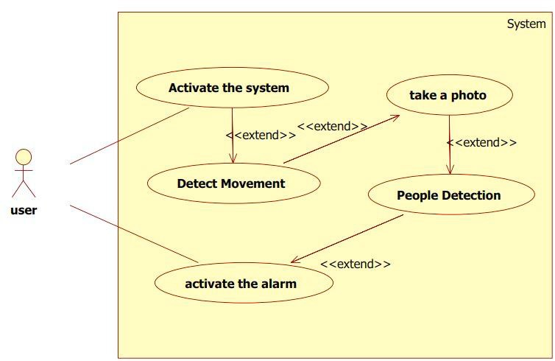

Fig. 4. Use Case Diagram

* 1. *Software Design*

After the hardware design, then we make a software design. Firstly, we make the use case diagram as shown by Fig. 4. The user starts to activate the system in Raspberry Pi 3. Movement detection is handled by PIR Sensor and Arduino send the value true or false to Raspberry Pi 3. Photo captured is triggered after Arduino send data. Raspberry Pi 3 control the camera.

For intruder detection, HOG and SVM are installed in Raspberry Pi 3. HOG is used to extract the features of human objects in the image. In the first step, the HOG method will convert RGB image (red, green, blue) to grayscale. Then gamma normalization will be done to calculate the result of the square root of each channel (red, green, and blue channel). Then, the gradient value of each pixel will be calculated by dividing it into 8x8 cells. The next process is to determine the number of orientation bin that will be used in the histogram (spatial orientation binning). After that the normalization process of block 16x16 will be done cells to overcome the lighting changes. In this process there are blocks that overlap due to their shifting cells. The final process is to calculate the HOG feature vector. The resulting HOG feature will be processed using the SVM method to determine whether the feature is a human feature or not. The full process of human detection can be seen in the Fig. 5.

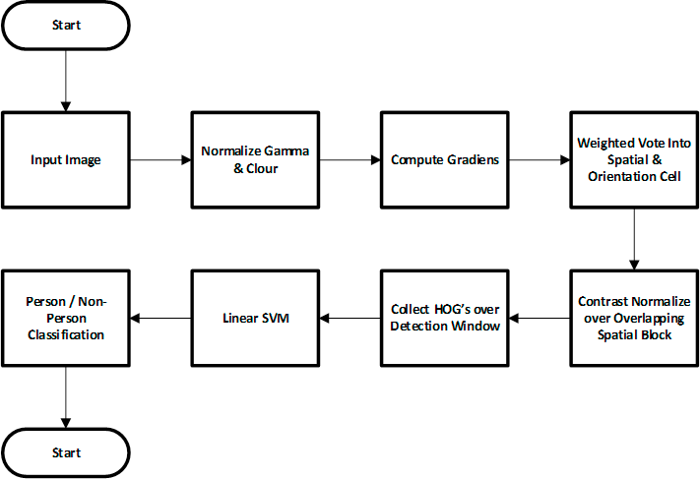

Fig. 5. Human Detection Process

# Result And Discussion

In this section, we discuss about the implementation of IoT security monitoring system dan evaluation result. Firstly, we integrate and implement the designed system as shown by Fig. 6. Fig 6(a), 6(b), and 6(c) shows the connection between Arduino with PIR sensor, connection between Arduino and Raspberry Pi 3, and connection between Raspberry Pi 3 with buzzer and webcam.

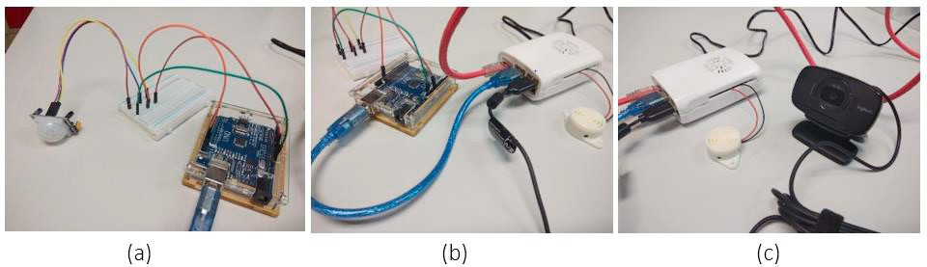 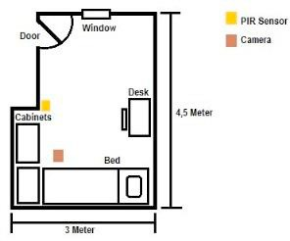

Fig. 6. (a) Arduino with PIR Sensor

1. Arduino connected with Raspberry Pi 3
2. Rasberry Pi 3 with Buzzer and Webcam

Fig.7. Test Environment

Fig 7 shows the sketch of evaluation environment. The entrance access to this room is through 1 door and 1 window. The PIR sensor and camera is located in front the door as shown by Fig. 7. The scenario of the evaluation is described as follow:

1. Firstly, we activate the system and the intruder will open the door and enter the room
2. The system will take a detect the movement of the intruder and take photos of the intruder
3. The system will analyze the existence of intruder and activate the buzzer.

This scenario is repeated for 100 times experiments with various condition of intruder, e.g. carrying goods, half standing, facing sideways, half body, etc as shown by Fig. 8. There are two parameters that we measure in this evaluation. First parameter is about the processing time of intruder detection. Second parameter is the accuracy of intruder detection.

Fig 9 shows the result of the processing time. The x-axis indicates the index of experiment (total of experiment is 100 times), while the y-axis indicates the measured time in seconds. Blue line indicates time to take pictures. It

means the time started from the PIR sensor detect the movement until photo is taken. Red line indicates time for human detection. It means the time started from take the picture, system analyze the picture, until the decision is made. The result shows that average time to take the picture is 0.924 second, while the average time to detect the intruder is 1.083 second. Therefore, the total time from movement detection until intruder image detection is 2.007 seconds. From the processing time measurement, we consider the system is capable to secure the house because it can detect the intruder within seconds.

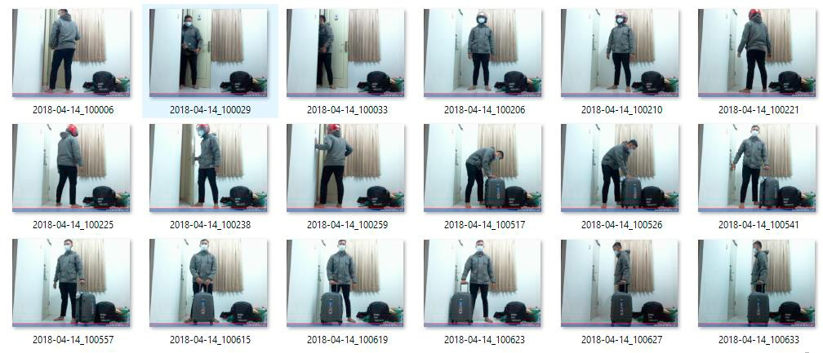

Fig.8. Sample of Captured Image

1.6

1.4

1.2

1

0.8

0.6

0.4

0.2

0

Time To Capture Image

Time To Human Detection

Fig.9. Intruder Detection Time

1

4

7

10

13

16

19

22

25

28

31

34

37

40

43

46

49

52

55

58

61

64

67

70

73

76

79

82

85

88

91

94

97

100

Then we evaluate the accuracy of the human detection process. From the experiment it produces 100 photos. From the photos, we detect the existence of people on the photo or in other words the system is able to detect people or not from the photos. From the results of checking, 89 images were successfully detected and 11 other images

could not be detected. We try to analyse about when the system successfully detects the intruder and when it does not successful in detecting the intruder. Sample of image for successful detection can be seen in Fig. 10. In this sample success, people in that photo have a contrast colour with background, like wall and door. Therefore, system can detect people in that photo easily. On the other hand, Sample image for failed detection can be seen in Fig. 11. In this sample photo, we find that system fail detect when any object blocking people’s shape, people in that photo has less contrast colour with background, like wall and door. When the extract feature is performed, the system does not precisely detect one's body. Therefore, SVM cannot classify well or assume that in the picture does not exist. From this result, we can evaluate that the system has good accuracy in detecting intruder, however it is interesting to improve the accuracy until 100% for the future research.



Fig.10. Sample Image of Successfully Detected Event

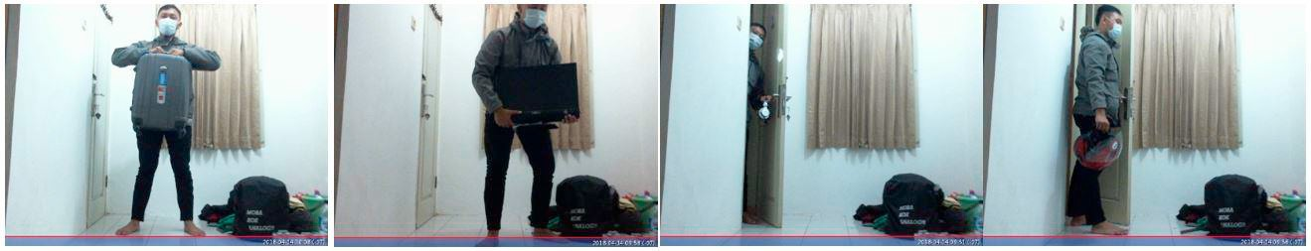

Fig.11. Sample Image of Fail Detected Event

# Conclusion

In this paper, we have proposed a security monitoring system based on IoT technology. Our propose system consists of Raspberry Pi 3, Arduino, PIR sensor, web camera and buzzer. The novelty of our proposed system is the inclusion of human detection capability by HoG and SVM method and buzzer as method to warn the house owner. The simulation result shows that system can detect the intruder within seconds with accuracy of 89%. For future research, we plan to explore other feature extraction and classification method to improve the accuracy of intruder detection.

# References

1. Bangali J, Shaligram A. Design and Implementation of Security Systems for Smart Home based on GSM technology. Int J Smart Home. 2013;7(6):201–8.
2. Charadva MJ. A Study of Motion Detection Method for Smart Home System GENERAL. 2014;1(5):148–51.
3. Chitnis S, Deshpande N, Shaligram A. An investigative study for smart home security: Issues, challenges and countermeasures. Wirel Sens Netw. 2016;8(4):61.
4. Ansari AN, Sedky M, Sharma N, Tyagi A. An Internet of things approach for motion detection using Raspberry Pi. In: Intelligent Computing and Internet of Things (ICIT), 2014 International Conference on. 2015. p. 131–4.
5. Chuimurkar RM, Bagdi V, Professor A. Smart Surveillance Security &amp;Monitoring System Using Raspberry PI and PIR Sensor. Int

J Sci Eng Appl Sci [Internet]. 2016;2(1):159–65. Available from: <http://ijseas.com/volume2/v2i2/ijseas20160217.pdf>

1. Dalal N, Triggs B. Histograms of oriented gradients for human detection. In: Computer Vision and Pattern Recognition, 2005 CVPR 2005 IEEE Computer Society Conference on. 2005. p. 886–93.
2. Tanwar S, Patel P, Patel K, Tyagi S, Kumar N, Obaidat MS. An advanced Internet of Thing based Security Alert System for Smart Home. In: Computer, Information and Telecommunication Systems (CITS), 2017 International Conference on. 2017. p. 25–9.
3. Satpathy A, Jiang X, Eng H-L. Human detection by quadratic classification on subspace of extended histogram of gradients. IEEE Trans Image Process. 2014;23(1):287–97.
4. Pi R. Raspberry Pi Model B. 2015.
5. Kumar AS, Reddy PR. An Internet of Things approach for motion detection using Raspberry-Pi. J Int J Adv Technol Innov Res. 2016;8(19):3622–7.
6. Abdullah R, Rizman ZI, Dzulkefli NNSN, Ismail SI, Shafie R, Jusoh MH. Design an automatic temperature control system for smart tudungsaji using Arduino microcontroller. ARPN J Eng Appl Sci. 2016;11(16):9578–81.
7. Badamasi YA. The working principle of an Arduino. In: Electronics, computer and computation (icecco), 2014 11th international conference on. 2014. p. 1–4.
8. Sahoo KC, Pati UC. IoT based intrusion detection system using PIR sensor. In: Recent Trends in Electronics, Information & Communication Technology (RTEICT), 2017 2nd IEEE International Conference on. 2017. p. 1641–5.